Kent Cycling Association

President: Mrs. Pat Hill
65th Roy Enfield Memorial 50 Mile Time Trial
Promoted for and on behalf of Cycling Time Trials under their Rules and Regulations
This event qualifies as a ‘SPOCO’ SE Group 3 Event
Sunday 16th August 2015

Course: Q50/11 | Start: 06.31
Timekeeper Mr Paul Mepham and Recorder Mr John Clegg (VC Elan)

Awards
Scratch
1st | Gilt Plated Medal
2nd | Silver Plated Medal
3rd | Bronze Medal
Best improvement on previous 3 year PB
1st | Gilt Plated Medal
2nd | Silver Plated Medal
3rd | Bronze Medal
Veteran on Standard
1st | Gilt Plated Medal
2nd | Silver Plated Medal
3rd | Bronze Medal
Fastest Lady  1st  2nd  3rd | Gilt Plated Medal  Silver Plated  Bronze Medal
Fastest Club Team of 3 Riders | Bronze Medals

Event Secretary
Rob Kennison, 16 Pintail Drive, Iwade, Kent ME9 8QW
Tel 01795 438837 Mobile 07759 319225
rob.kennison@me.com

IN THE INTERESTS OF YOUR OWN SAFETY,
Cycling Time Trials and the event promoters strongly advise you to wear
a HARD SHELL HELMET that meets an internationally accepted safety standard.

In accordance with Regulation 15 ALL JUNIOR competitors must wear
Protective Hard Shell Helmets.

It is recommended that a working rear light, either flashing or constant, is fitted to the machine
in a position visible to following road users and is active whilst the machine is in use.

Numbers will be at HQ (and not the start) and may be exchanged for a drink after. Riders are required to sign on before collecting their number.

Event Headquarters

HQ Brenzett Village Hall, King Street Brenzett. Coming from A2070 direction, turn right onto B2080 at Brenzett RAB (junction of A2070/A259/B2080) proceed to next minor RAB (200yds). King St is 1st exit. Hall is short distance along on right. The HQ will open at 5.30am. Please use field at rear of hall for additional parking – do not park in road.
NO SHOE PLATES IN HALL.
Please ensure your number is fitted in the correct position i.e. centrally positioned below the waist & can be easily read from the rear when you are in your normal riding position. PLEASE CHECK THIS. A MISSED NUMBER COULD BE A MISSED TIME.

Information for competitors

- Competitors must personally sign the signing-on sheet or they will not be allowed to race. Signing-on sheets and race numbers will be at the headquarters.

- Please keep the noise to a minimum to avoid unnecessary disturbance to the local residents, Turbo trainers or rollers are not to be used at or in the vicinity of the Headquarters.

- Competitors or their helpers must not park in the vicinity of the start or finish. Under no circumstances should competitors approach the timekeeper.

- Do not perform U-turns in the Start and Finishing.

- Allow plenty of time to ride to the start point.

- Directions to the start: Turn left from the HQ car park and at the roundabout take the third exit, at the next roundabout take the first exit onto the A2070 towards Ashford, and continue for approximately three miles to turn right at Johnson’s Corner towards Ham Street. GREAT CARE, follow road to the start on the opposite side of the road. Take GREAT CARE when turning for the start.

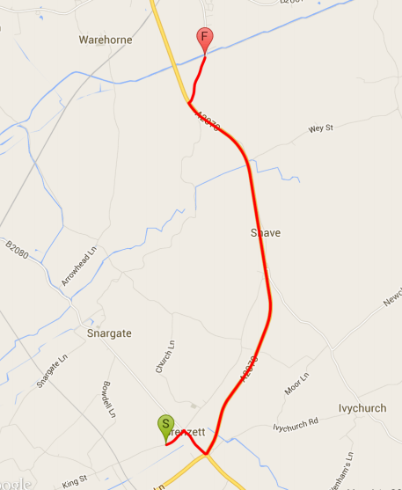 Route to Start

Q50/11 course detail

Ham Street – Brenzett - Brookland – Lydd – Brenzett – Ham Street

Start on old road at Ham Street (TR004327) under high power lines south of Mountain Farm entrance, proceed to Johnsons Corner to join A2070 (0.6miles)
Proceed south on A2070 to Brenzett RAB (3.95miles)
Take second exit at Brenzett RAB junction of A259/A2070/B2080 on to A.259 and follow via Brookland RAB to East Guldeford where left via Camber to Lydd, skirting the town. Straight on at Lydd RAB to join the B.2075 at ‘T’ junction where turn right (care) and proceed to Hammonds Corner where left onto A.259 to Brenzett RAB (25.34 miles) Take first exit to Brookland RAB and then complete further circuit to Brenzett RAB (46.73 miles)
Take 3rd exit (CARE) onto A2070 to finish 12 metres north of lamppost No UAT 005 at North end of layby, approx. 100m South of Johnson’s Corner. (50 miles)

KCA 50 Mile Time Trial Q50/11 16th August 2015

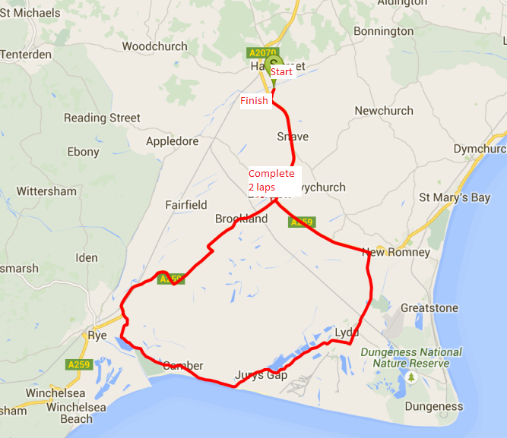

KCA 50 Mile Time Trial Q50/11 16th August 2015

No. | Name | Club | Cat. | LTS | Vet Std. | Start
1 | Amber King | TriSpirit Team | WV47 | 02:37:50 | 02:29:47 | 06:31
2 | Eva Nyirenda | …a3crg | WV30 | 02:09:45 |  | 06:32
3 | Colin Inett | Thanet RC | V74 | 02:20:46 | 02:38:23 | 06:33
4 | Sara Barman | Dulwich Paragon CC | WV42 |  | 02:27:23 | 06:34
5 | Martin Brown | 7 Oaks Triathlon Club | V54 | 01:58:19 | 02:21:49 | 06:35
6 | Iain Boardman | Dulwich Paragon CC | V42 | 02:04:16 | 02:16:32 | 06:36
7 | Andy Burrows | Thanet RC | V72 | 02:16:38 | 02:35:43 | 06:37
8 | Jim Hollands | Rye & District Wheelers CC | V75 | 02:36:50 | 02:39:51 | 06:38
9 | Paul Morton | PMR @ Toachim House |  |  |  | 06:39
10 | Malcolm Davies | VC Elan – Harry Perry Cycles | V40 | 01:57:15 | 02:15:35 | 06:40
11 | Gary King | Rye & District Wheelers CC | V54 | 02:00:51 | 02:21:49 | 06:41
12 | Nigel Perry | San Fairy Ann CC | V51 | 02:08:16 | 02:20:27 | 06:42
13 | Paul Cloudsdale | Bigfoot CC | V42 | 02:20:15 | 02:16:32 | 06:43
14 | Dace Homa | Rye & District Wheelers CC | WV52 |  | 02:32:10 | 06:44
15 | Steven Smith | Medway Velo Club | S38 | 01:58:05 |  | 06:45
16 | Christopher Bax | PMR @ Toachim House | V63 | 02:04:14 | 02:27:06 | 06:46
17 | Tom Morton | PMR @ Toachim House | V60 | 02:16:00 | 02:25:05 | 06:47
18 | Richard Leslie | Kingston Wheelers CC | S33 | 02:25:00 |  | 06:48
19 | Jamie Alldridge | Folkestone Velo Club | S33 |  |  | 06:49
20 | Simon Henderson | Thanet RC | V52 | 01:56:16 | 02:20:54 | 06:50
21 | Michael Gore | Medway Velo Club | S37 | 02:00:52 |  | 06:51
22 | Michael Coulter | Gravesend CC | V67 | 02:07:48 | 02:30:22 | 06:52
23 | Michael Morris | Cycle Club Bexley | V72 | 02:18:39 | 02:35:43 | 06:53
24 | Andrew Carson | Deal Tri | S32 |  |  | 06:54
25 | Tim Kingston | Deal Tri | V40 | 01:58:04 | 02:15:35 | 06:55
26 | Dominic Campbell | Medway Velo Club | S24 | 02:04:01 |  | 06:56
27 | Malcolm Coshell | Rye & District Wheelers CC | V42 | 02:14:41 | 02:16:32 | 06:57
28 | Peter Hayes | Catford CC | V70 | 02:24:54 | 02:33:22 | 06:58
29 | Jamie Scott | Kingston Wheelers CC | S38 |  |  | 06:59
30 | Mike Piper | Abellio – SFA Racing Team | S39 | 01:54:21 |  | 07:00
31 | Huck Garip | Thanet RC | V43 | 02:00:13 | 02:16:59 | 07:01
32 | Malcolm Daly | Hastings & St. Leonards CC | V55 | 02:05:15 | 02:22:19 | 07:02
33 | Lee Kingston | Medway Velo Club | V41 | 02:18:35 | 02:16:04 | 07:03
34 | Spencer Wood | Adalta Cycling Club | S39 |  |  | 07:04
35 | Peter Pav Bryan | Rye & District Wheelers CC | S29 | 01:57:56 |  | 07:05
36 | Colin Newton | Folkestone Velo Club | S28 | 02:03:49 |  | 07:06
37 | James Dickson | Thanet RC | V50 | 02:13:11 | 02:20:00 | 07:07
38 | Russ Mason | Thornton Road Club | V66 | 02:24:26 | 02:29:29 | 07:08
39 | Ben Houston | East Grinstead CC | S38 |  |  | 07:09
40 | Sam Bradford | PMR @ Toachim House | S21 | 01:54:00 |  | 07:10
41 | Richard McVey | Adalta Cycling Club | V50 | 01:58:50 | 02:20:00 | 07:11
42 | Mark Amon | Rye & District Wheelers CC | V50 | 02:04:52 | 02:20:00 | 07:12
43 | Keeley Chalk | PMR @ Toachim House | W46 | 02:18:17 | 02:29:19 | 07:13
44 | Mike Perry | San Fairy Ann CC | V70 |  | 02:33:22 | 07:14
45 | Andrew Buckley | Adalta Cycling Club | S38 | 01:57:47 |  | 07:15
46 | Mark Whittaker | GS Invicta – Eye Level Optical | V44 | 02:01:46 | 02:17:26 | 07:16
47 | Anthony Smith | Bournemouth Arrow CC | V55 | 02:12:35 | 02:22:19 | 07:17
48 | Jill Cliff | GS Invicta – Eye Level Optical | WV45 | 02:22:05 | 02:28:51 | 07:18
49 | Debbie Milton | TriSpirit Team | WV40 |  | 02:26:20 | 07:19
50 | Andrew Meilak | VeloRefined Aerosmiths | V49 | 01:50:14 | 02:19:34 | 07:20
51 | John French | Oxford City Road Club | V62 | 01:59:25 | 02:26:24 | 07:21
52 | Paul Fairman | Abellio – SFA Racing Team | V60 | 02:04:23 | 02:25:05 | 07:22
53 | Robert Sissons | San Fairy Ann CC | V62 | 02:18:00 | 02:26:24 | 07:23
54 | Brian Paterson | Thornton Road Club | V49 |  | 02:19:34 | 07:24
55 | Kevin Grimshaw | Bigfoot CC | V49 | 01:57:39 | 02:19:34 | 07:25
56 | Lee Russell | VC Elan – Harry Perry Cycles | V40 | 02:01:16 | 02:15:35 | 07:26
57 | Danny Frost | Folkestone Velo Club | V51 | 02:11:16 | 02:20:27 | 07:27
58 | Andy Macpherson | VC Deal | V48 | 02:21:49 | 02:19:09 | 07:28
59 | Mark Foulds | Bowlphish Bontrager Racing | V44 |  | 02:17:26 | 07:29
60 | Kevin Tye | VeloRefined Aerosmiths | V53 | 01:41:37 | 02:21:21 | 07:30

